**CHAPTER 8: CREATING AN APP’S NAVIGATION**

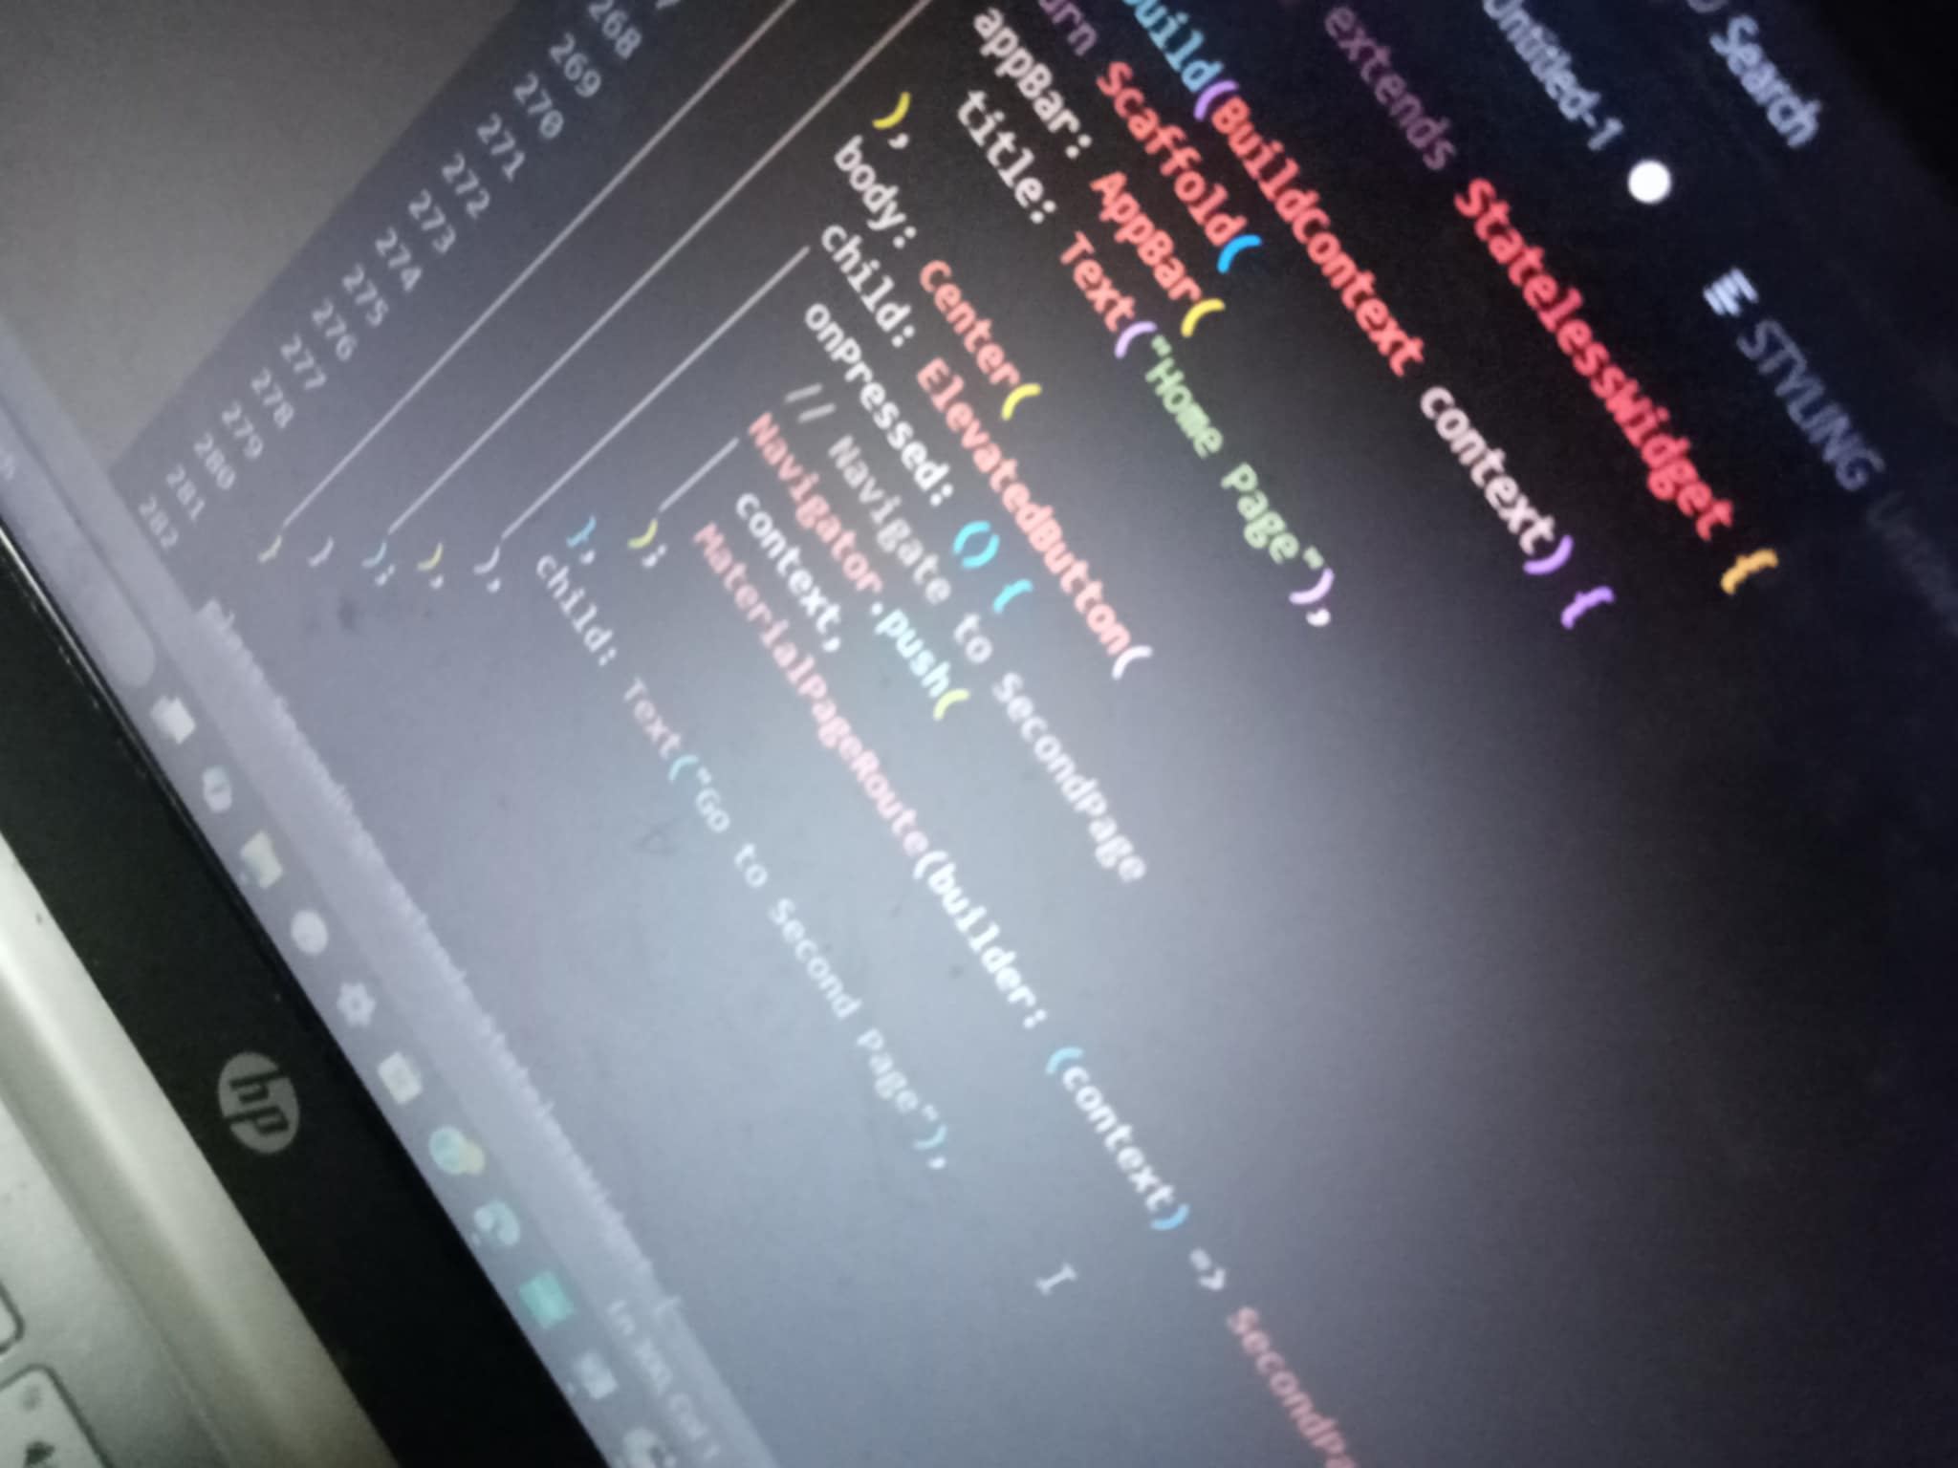Creating navigation in an app is essential for guiding users through different screens and sections of the application. Navigation allows users to interact with the app’s various features, and how you implement it depends on the platform or framework you're using